

**————————————————————**

*Scientific Methods and Writing*

Assignment 2

**————————————————————**

Lecturer： Lang, Stefan

Augustin, Hannah Lucille

Stu-Name： Chen, Yuzhou

Stu-number： s1104123

Major： Applied Geoinformatics

Winter semester, 2023

**Exploring the impact of spatial morphology of terraces on soil erosion from digital elevation model with high spatial resolution**

**1 Introduction**

Influenced by factors such as climate, topography, soil composition, and hydrological characteristics, soil erosion varies among different geographical locations. This phenomenon involves the transport of soil particles primarily due to external forces, leading to ecological and environmental issues such as declining soil fertility and desertification (Bao et al., 2022). So, terracing has emerged as a common soil and water conservation practice in areas prone to erosion on sloping terrains, aiming to mitigate erosion intensity in watersheds and enhance local ecological conditions. Terraces typically denote step-like fields aligned with the contour of slopes in mountainous and hilly terrains, effectively reducing runoff and soil erosion (Zhu et al., 2011;Wang et al., 2017). Notably, topographic factors, including slope gradient and length, play pivotal roles in assessing soil erosion effectiveness in stripping and soil-water transportation (Yang et al., 2006). However, constrained by the second law of geography, the distinct morphological attributes and spatial arrangement of terraces significantly impact the intensity and distribution of soil erosion. This is attributed to the inherent morphology of terraces, mirroring the original slope pattern. Even within a confined area, terraces exhibit morphological diversity due to slope topography variations, encompassing width of terraced fields, height of sharp inclines, and other morphological elements (Zhu et al., 2011). Therefore, based on high-precision Digital Elevation Model (DEM) data, this study employs the Digital Terrain Analysis (DTA) method alongside the Revised Universal Soil Loss Equation (RUSLE) model to assess soil erosion changes in terraced versus non-terraced scenarios, elucidating the relationship between sample area terraces' comprehensive morphological factors and average soil erosion levels in subsequent investigations.

**2 Study Area and Data**

The study area is a watershed named Yaojiawan on the Loess Plateau of China, and covers 1.803 *km2* in the range of 37°32´ N, 110°14´ E to 37°30´ N, 110°16´ E (Fig 1). The area contains many valleys and slopes, complex topography, and the development of the 'Liang' landform. It is a transition zone from an inland arid climate to a warm-temperate humid monsoon climate, with an overall semi-arid climate, and the concentrated summer rainfall is the main driver of soil erosion in the watershed. The mountain slopes of Yaojiawan are generally arranged in longitudinal columns with terracing works, occupying more spatial weight, which makes the region very suitable for comparative study of terraced soil erosion.

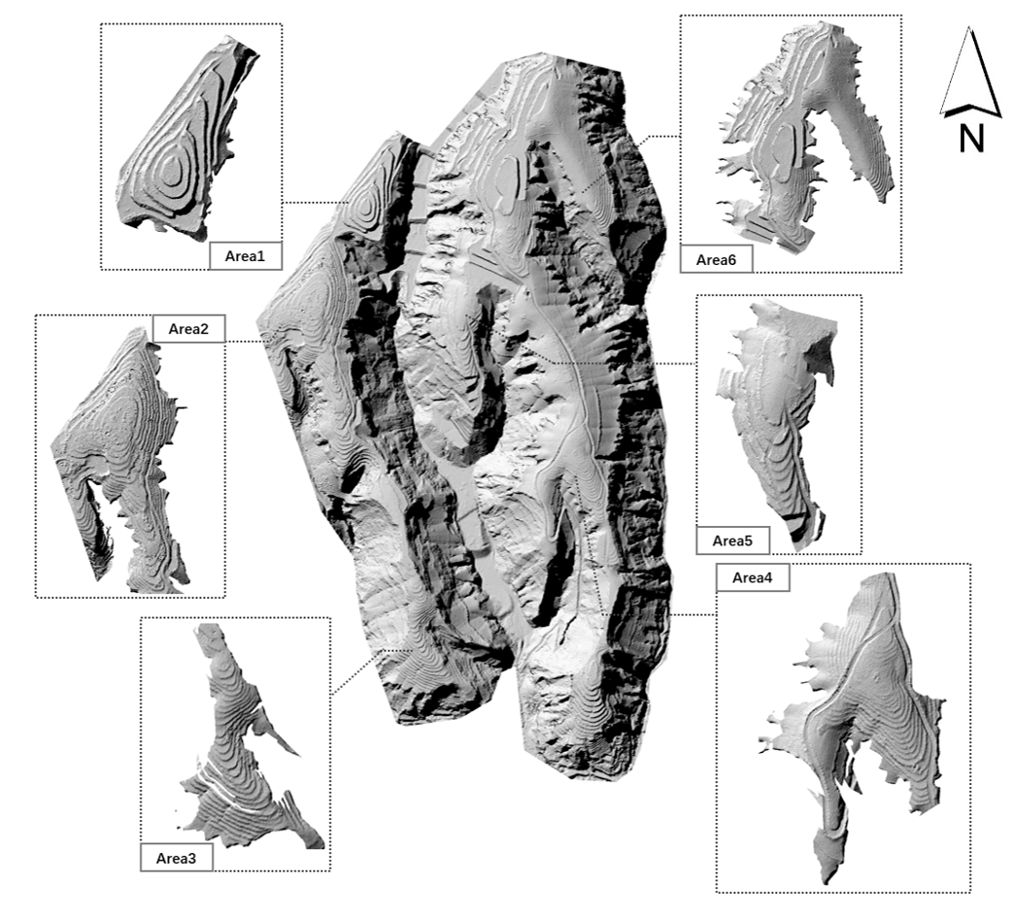

Fig 1. Hillshade of the study area

Considering the heterogeneity of terrace morphology in Yaojiawan, based on the pre-processed DEM of the total area of the study area, a suitable small-area DEM was cropped to carry out the study based on the distribution of typical terraces. The DEM data of the sample area was interpolated from the 0.01m resolution high-precision surface dense point cloud data measured by UAV, with a spatial resolution of 0.1 *m*. The point cloud was generated in August 2019, and the average ground sampling distance (AGSD) of the original aerial film image was 4.53 *cm*/1.78 *in*.

The data was used to calculate the slope topography factor *LS*. In addition, other environmental factors in RUSLE were calculated based on the meteorological data, spatial distribution of soil types, vegetation characteristics, and effectiveness of the slope protection project in the study area, respectively.

**3 Method**

**3.1 RUSLE: Soil erosion evaluation model**

The extent of soil loss was quantified through the soil erosion modulus, indicating the overall soil erosion per unit horizontal projected area within a specific timeframe. Given the arid climate prevailing in the study area characterized by concentrated summer precipitation and hydraulic erosion dominance, the RUSLE model, originally developed in the agricultural context of the central United States, was employed in this research to compute the soil erosion modulus in the study area.

*(1)*

where, *A* represents the annual soil erosion per unit area [t/(hm²·a)], *f* denotes the modification constant; *R* stands for the rainfall erosivity factor [MJ.mm/(hm²·h·a)]; *K* signifies the soil erodibility factor [t·hm²·h/(hm²·MJ·mm)]; *LS* denotes the slope length factor, dimensionless; *C* signifies the vegetation cover factor, dimensionless; *P* represents the factor of soil and water conservation measures, dimensionless, within a value range of [0,1], and *P=1* when the area is distributed with forest land.

The topography profoundly governs the mechanisms of soil and water transport within the region, acting as a locus for both soil erosion and a fundamental influencer in the soil erosion development process. It holds a pivotal role in accumulating and redistributing material and energy across the surface. Notably, prior to and following the implementation of terraces, the most notably altered factor in the equation is the slope length factor *LS* (Zhang et al., 2022). Hence, a mathematical model becomes indispensable for terracing.

**3.2 Spatial morphology and destruction of terraced fields**

Terraces within Yaojiawan exhibit various morphological traits, categorized into slope terraces, horizontal terraces, and reverse slope terraces. The basin's terraces display a generally flat and gently undulating surface, with horizontal terraces being the primary type. Efficiently modeling terraces involves their extraction along with the corresponding constraint lines (Fig. 2a). This study aims to assess the alterations in soil erosion within the sample area pre- and post-terrace construction. Given that the current Digital Elevation Model (DEM) of the sample area already includes terraces, it becomes essential to generate a hypothetical natural surface DEM devoid of terraces through a de-terracing method. Subsequently, the spatial morphology of the terraces will be calculated for both pre- and post-construction scenarios.

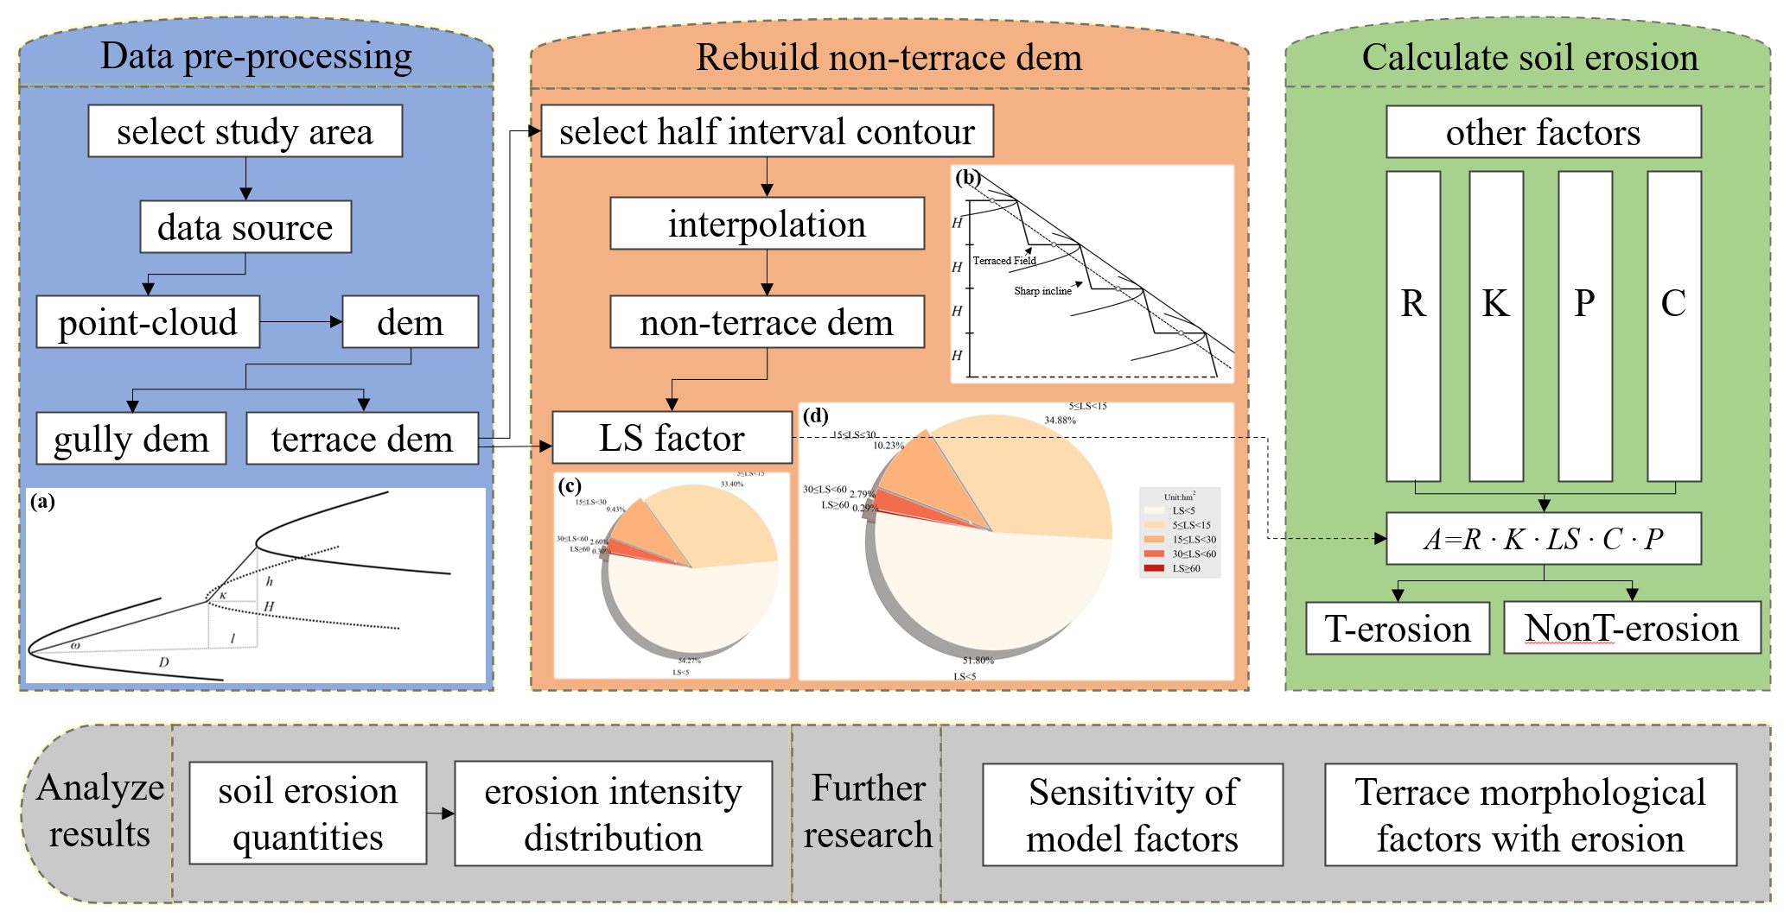

Fig 2. Overall work flow

In terraces, contour lines running parallel to the table edge line and the table edge offset line were extracted from the field surface of each terraced field layer in the study. These contour lines served to depict the elevation of the terraced field at each layer, with the contour distance set as the average height of the canopies within the sample area, denoted as *h*. Subsequently, these contour lines were interpolated to generate a new DEM representing terrace-free fields. Utilizing the data obtained from both terraced and non-terraced fields, and the *LS* factor, crucial for characterizing the spatial morphology of terraced fields, was computed at the watershed scale.

*(2)*

where, *L* is the length of the hillside (m); *L0* = 22.1 m is the length of the standard USLE experimental slope; *θ* is the slope expressed as an angle; *m* is a variable exponent ranging from 0.2 to 0.5, determined by the slope.

**3.3 Assessment of other factors in RUSLE**

1）Rainfall erosivity factor *(R)*

Precipitation is the primary catalyst for soil erosion, with factors such as rainfall process duration, intensity, type, and total precipitation significantly influencing soil loss (Zhang et al., 2021). Within this study, the 2019 precipitation records for Suide County, encompassing the location of Yaojiawan, were obtained. We utilized the daily rainfall intensity assessment model originally proposed by Wischmeier (1959) but revised by Zhang (2002), to compute the rainfall erosive potential in the Yaojiawan area.

*(3)*

2）Soil erodibility factor *(K)*

*K* factor gauges the natural vulnerability of soil to erosion. Within this study, the estimation of the *K* factor was conducted using the *EPIC* equation—an erosion and productivity evaluation model introduced by Williams (1996). Mapping was performed to delineate the distribution patterns of three distinct soil types. Leveraging the geographical coordinates of the Yaojiwan sample area, local soil characteristics and organic carbon content were extracted, enabling the determination of mass fractions for sand, silt, and clay.

*(4)*

3）Cover management factor *(C)*

*C* factor represents the erosion ratio under a particular vegetation cover and management compared to erosion in bare fallow cropland, varying between 0 and 1. Elevated *C* values tend to mitigate and restrain soil erosion. To compute this factor, the assessment equation formulated by Sulistyo (2016) was employed in this study.

*(5)*

4）Conservation practice factor *(P)*

*P* factor is related to the land use status of the region, drawing on a soil erosion study that also selected the Loess Plateau as a sample area, thus assigning a value to the *P* factor (Wu et al., 2021).

**4 Result**

This study utilized Digital Elevation Model (DEM) data from both terraced and non-terraced fields within the Yaojiawan watershed area as topographic morphology data. These datasets were integrated with other pertinent environmental factors in the region. Employing the RUSLE model, the research aimed to evaluate the variation in soil erosion modulus and erosion intensity within the watershed's spatial scale concerning the presence or absence of slope terracing projects.

The result shows that, the conversion of the natural slope to the terraced field will significantly impact slope length factor *LS*, and then change the total amount and distribution of soil erosion in the basin (Fig 3).

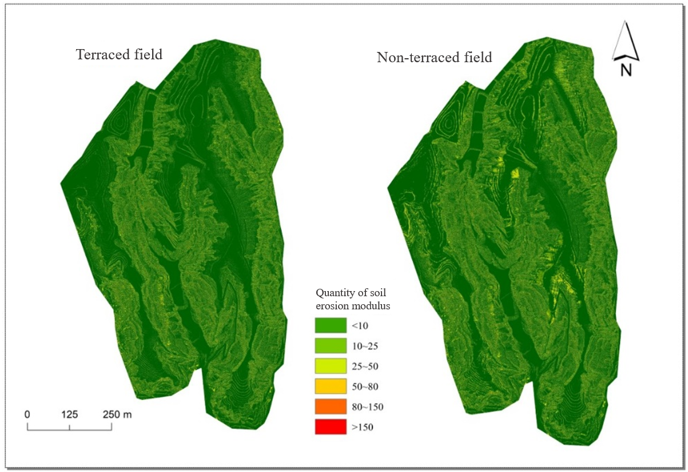

Fig 3. Distribution of soil erosion modulus before and after terrace construction

After the terraced field construction, the total area of soil erosion decreased by 25%, from 23.59hm2 to 17.76hm2 under simulated terraced field removal(Fig 4), while the erosion rate decreased from 8.97 t/(hm2·a) to 7.65 t/(hm2·a). It is inferred that the annual rate of soil erosion loss in the sample area will decrease from 211.98t/a to 136.25t/a, which is improved compared with the extent and intensity of erosion before terraced field construction.

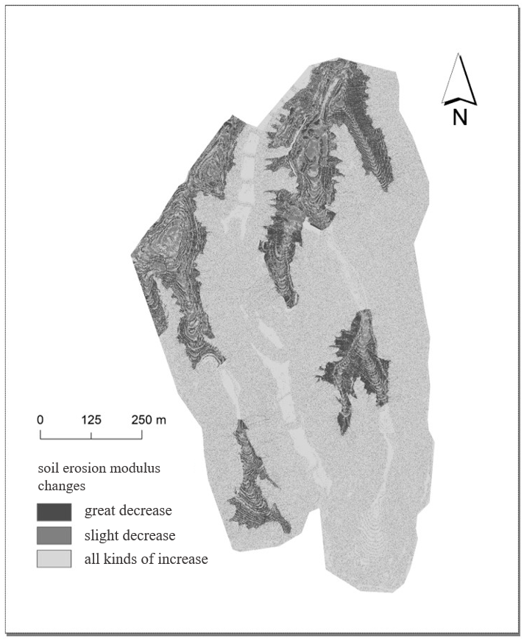

Fig 4. Changes in soil erosion modulus in before and after terrace construction

The calculation results of several typical terraced fields consistently show that terraced fields can reduce the total soil erosion on corresponding slopes by about 50%. In the slope with terraced fields, the erosion coverage of light intensity and below intensity increased compared with that without terraced fields. In the area with terraced fields, the overall soil erosion rate slowed down, and the moderate and above intensity erosion was significantly improved.

**5 Discussion**

While previous studies have dived into the impact of terrace construction on soil erosion from diverse perspectives, it is evident that significant avenues of research remain unexplored. Beyond slope gradient and length, terrace morphology encompasses additional aspects, including terrace width, narrowness, field area slope spectra, and other expressions. Future investigations can adopt mathematical approaches to elucidate the correlation between these terrace characteristics and the pre- and post-erosion alterations. This approach aims to augment both the breadth and depth of the study, enriching our understanding of the subject.

**References**

Bao Y B, Huang T, Lv L T. Soil conservation effect after implementing the project of returning farmland to forest and grassland in the Loess Plateau of northern Shaanxi, Journal of Ningxia University, 2022(03), 1-8.

Ghosal, K., Das Bhattacharya, S. A Review of RUSLE Model. J Indian Soc Remote Sens 48, 689–707 (2020).

Sulistyo, B., The effect of choosing three different C factor formulae derived from NDVI on a fully raster-based erosion modeling. 2016, IOP Conf. Series: Earth and Environmental Science, 47, 012030.

Walter H. Wischmeier. A Rainfall Erosion Index for a Universal Soil-Loss Equation[J]. Soil Science Society Proceedings, 1959, 23(3): 246-249.

Williams J, Nearing M, Nicks A, et al. Using soil erosion models for global change studies[J]. Journal of Soil and Water Conservation, 1996,51(5):381-385.

Wang Y R, Zhao M D, Feng Y, Zhang Q. Study on the disturbance characteristics of terraces on soil erosion topographic factors. Journal of Shandong Agricultural University (Natural Science Edition), 2017, 48(01): 46-51.

Wu C C, Wang S J. Evaluation of soil erosion sensitivity in the Lanzhou section of the Yellow River Basin. Science, Technology and Engineering, 2021, 21(29): 12390-12397.

Yang L, Li T W, Wang W X, Liu X J. Discussion on the three-dimensional modelling method of terraces in micro-geomorphology of Loess Plateau. Journal of Northwest University (Natural Science Edition), 2006(02): 321-324.

Zhang W B, Xie Y, Liu B Y.A study on the method of calculating rainfall erosivity using daily rainfall. Geoscience, 2002(06): 705-711.

Zhu S J, Tang G A, Zhang W, Zhao W D. Research on rapid construction method of terrace DEM. Surveying and Mapping Bulletin, 2011(04): 68-70+82

Zhang X Y. Study on the distribution law of soil erosion and the amount of erosion in Yili, Xinjiang. Heilongjiang Water Resources Science and Technology, 2021, 49(08): 8-12.

Zhang G H, Yang Y, Liu Y N, Wang Z Q. Progress and prospects of soil erosion research in the Northeast Black Soil Region, Journal of Soil and Water Conservation, 2022(03), 1-12.